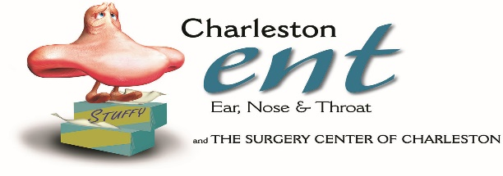 **EUSTACHIAN TUBE BALLOON DILATION**

**DISCHARGE INSTRUCTIONS**

**FOLLOW UP CARE**

* For 1 week post procedure, patients should adhere to the following:
* Avoid performing Valsalva maneuver
* Avoid nose blowing
* Avoid using CPAP machine (if possible)
* Sleep with an extra pillow to elevate the head
* After 1 week, it is recommended that all patients perform the Valsalva maneuver one time per hour for 24 to 48 hours.
  + Proper Valsalva maneuver technique consists of holding the nose, blowing slowly to build pressure and then swallowing hard
* For 6 weeks post procedure, patients should use an inhaled nasal steroid spray
* If a follow up appointment was not made the day of surgery, please call the office to make one

**ACTIVITY**

* Do not drive for 24 hours or while taking narcotic pain medication

**DIET**

* Resume previous diet as tolerated

**MEDICATIONS**

* Prescription (s) will be sent with you. Use as directed.
* See PAIN CONTROL sheet for additional instructions.

**PROBLEMS TO WATCH FOR**

* Fever over 101.4
* Uncontrolled Nausea/Vomiting

**Call your doctor with ANY problems that concern you:** Phone # (843) **766-7103**. If you need immediate attention, go to the nearest Emergency Department.

**I have read, been read, and verbally repeated back instructions and understand them. A copy has been given to me.**

**Date of Follow-Up Visit ___________________ Time ________________**

**______________________________ _______________________________**

**Patient/Responsible Party Nurse Signature**