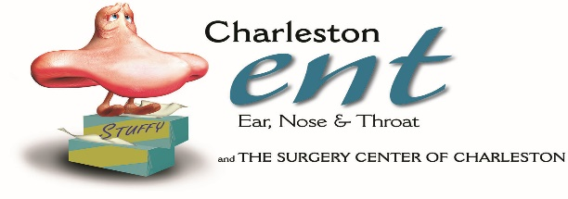 **RHINOPLASTY/NASAL RECONSTRUCTION**

**DISCHARGE INSTRUCTIONS**

**FOLLOW UP CARE**

* Black and blue eyes and swelling are normal and usually resolves within 2 weeks
* Avoid damage/trauma to the nose
* If you are involved in sports activities you must wear a protective mask
* If a follow up appointment was not made the day of surgery, please call the office to make one

**OPERATIVE SITE**

* Do not dislodge or remove the cast on the nose, it may loosen or fall off prior to your follow up appointment. DO NOT ATTEMPT TO PUT BACK ON.

**ACTIVITY**

* Do not drive for 24 hours or while taking narcotic pain medication
* Avoid vigorous activity or heavy lifting for 2 weeks

**DIET**

* Resume previous diet as tolerated

**MEDICATIONS**

* Prescription (s) will be sent with you. Use as directed.
* See PAIN CONTROL sheet for additional instructions.

**PROBLEMS TO WATCH FOR**

* Fever over 101.4 • Uncontrolled Nausea/Vomiting
* Heavy bleeding from the nose

**Call your doctor with ANY problems that concern you:** Phone # (843) **766-7103**. If you need immediate attention, go to the nearest Emergency Department.

**I have read, been read, and verbally repeated back instructions and understand them. A copy has been given to me.**

**Date of Follow-Up Visit ___________________ Time ________________**

**______________________________ _______________________________**

**Patient/Responsible Party Nurse Signature**